Computer Architecture – Term Project Nada Hamada 20101043

Single cycle MIps

# Screenshots of the simulation

### 

# Screenshot of the Code Components

# 

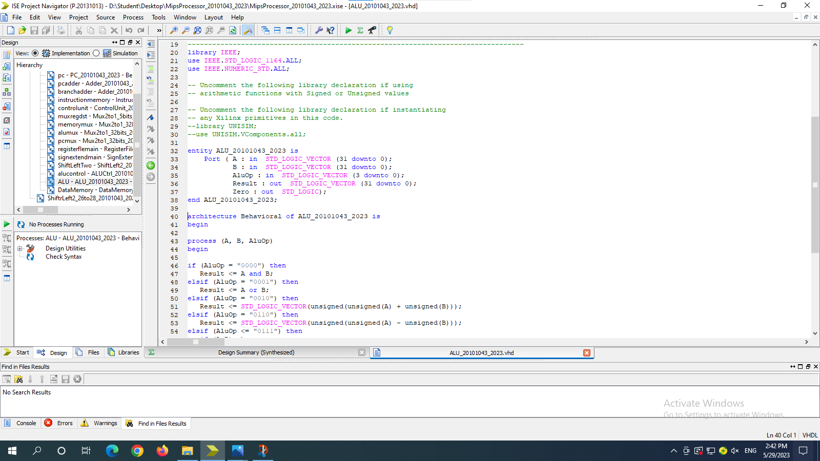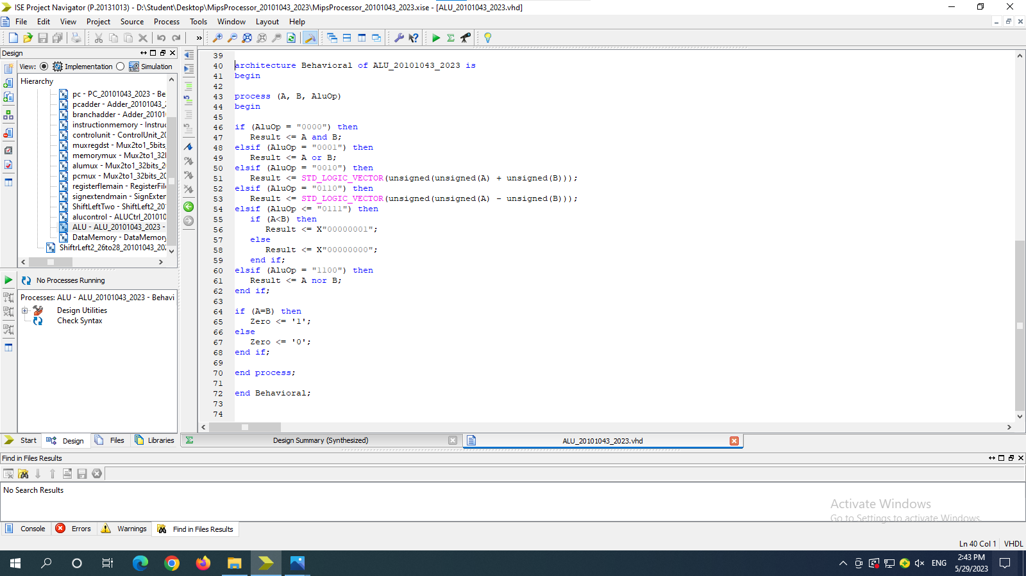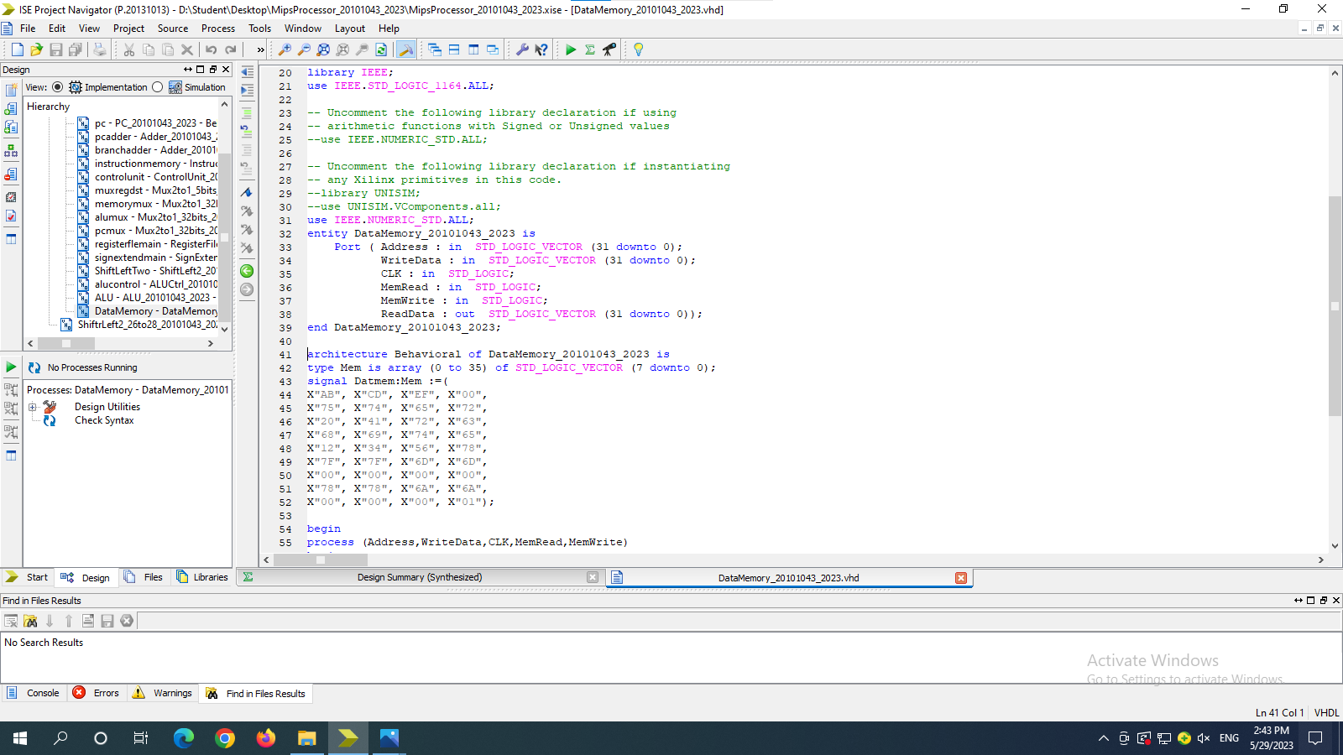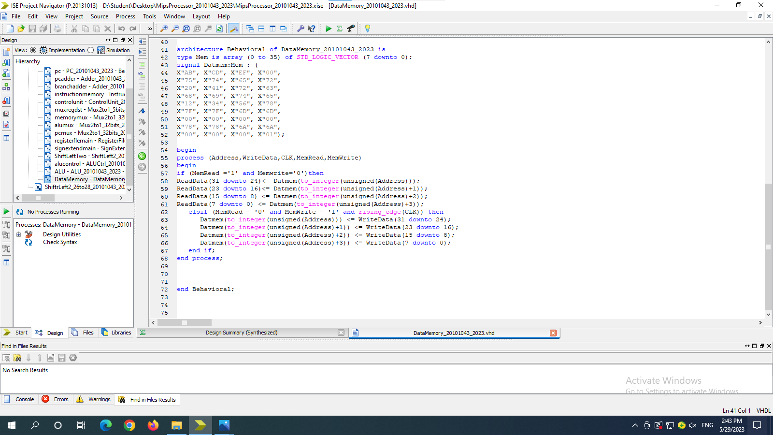

# Screenshot of Tested Instructions

